Health Benefits Open Enrollment period CY 2025 Plan Year is October 15 to November 8, 2024

IMPORTANT 2025 Updates
- Healthcare FSA increase to $3,200
  - Employees must re-enroll in the Flexible Spending accounts – they do not roll over to the new plan year
- New Prescription Drug Vendor, MedImpact: MedImpact is the State of Maryland’s Pharmacy Benefits Manager (PBM) effective January 1, 2025.
  - MedImpact Healthcare Handbook (pdf)
  - MedImpact FAQs (pdf)
  - All employees enrolled in the Prescription Drug plan will automatically receive new Prescription Cards in the mail between 12/10/2024 and 12/15/2024.
  - Prescription Drug plans are not included in any of our Medical Plans. You must be enrolled separately in order to have prescription drug coverage.

2025 Benefits Guide and Rates
Health Benefits Guide 2025 (pdf)
My MD Benefits Information Site
CY 2025 Regular Faculty and Staff Rates (pdf)
Contingent Faculty and Staff Rates (CY 2025) (pdf)

How to Enroll or Make Changes - Link to Workday
First Step
- Locating Your W Number
  - Go to Maryland Connect Workday
  - Click View Your Profile
  - Go to Personal tab on the left side of the page
  - Go to the ID tab at the top of the page
  - View your SPS W# number (it will be on the center right hand side of the table)
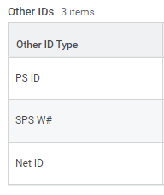
Your SPS W# will be listed on the same row, off to the right

Second Step
- Navigating to SPS Workday
  - In Maryland Connect Workday go to MENU in the upper left corner
  - Scroll down to External Links and select SPS Login (Online Health Benefits)
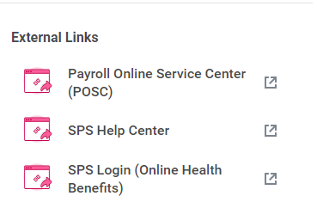
  - 2-Factor Authentication
    - Please be aware that you must have 2-factor authentication set-up in order to access your benefits information. Refer to OneLogin/Workday (pdf) if you have not previously done so.
All eligible faculty and staff will receive an Open Enrollment event in SPS Workday. There are two ways you can see your Open Enrollment event:
- Your SPS/Workday Inbox
- In the Announcements section on your SPS/Workday home screen

