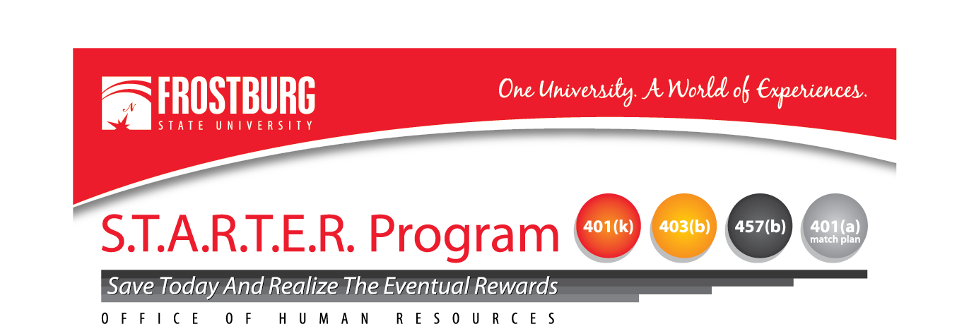

MEMORANDUM

To : All Faculty and Staff
From : Lee Ann Nightingale, Manager, Benefits & Wellness Program
Date : January 2023
Subject : Supplemental Retirement Plans

All faculty and staff employees at Frostburg State University (regular and contingent) are eligible to participate in Supplemental Retirement/Tax Deferred Investment plans (SRA) offered by the Maryland Supplemental Retirement Plans (MSRP) and the University System of Maryland (USM).

The MSRP plans are administered by Nationwide Retirement Solutions and include the following options :
- 457(b) Deferred Compensation Plans
  - Pre-Tax option
  - After-Tax Roth option
- 403(b) Tax Deferred Annuity Plan
- 401(k) Savings/Investment Plan
- Pre-Tax option
- After-Tax Roth option

The USM offers pre-Tax 403(b) and 457(b) plans and post-Tax 403(b) plans with Fidelity and TIAA .

Participation in any of the above plans is voluntary and can be initiated at any time during the year. Keep in mind that it is never too soon – or too late – to begin investing. Enrolling is the first step toward being ready for retirement as these plans are an excellent opportunity for employees to contribute their money for additional retirement security.

SRA Plan materials are available upon request from the Office of Human Resources by contacting Lee Ann Nightingale at 301/687-4398 or email lnightingale@frostburg.edu.

